VersionOne Salesforce.com CaseConnect

Post Install Instructions

# Overview

CaseConnect is VersionOne’s integration with Salesforce Cases. This integration creates Defects in VersionOne based on Cases in Salesforce.com. Using this integration your organization can leverage its investment in Salesforce Cases Management as part of an integrated platform for Agile development.

Once the integration is installed and configured, Salesforce users can specify which Cases require engineering attention and associate them with VersionOne Defects. Salesforce users can choose to create a new VersionOne Defect or assign the Case to an existing VersionOne Defect.

After the association is made, the Salesforce user can view the VersionOne Defect from Salesforce and can publish the VersionOne Defect Status to the Salesforce Case.

# System Requirements

### VersionOne

The integration is supported with the following VersionOne editions

* Team
* Enterprise
* Ultimate

Your VersionOne instance must be accessible from the internet in order to use CaseConnect.

### Salesforce.com

The integration was been tested with the Summer 2010 release of Salesforce.com in the following editions

* Enterprise
* Developer

# Download and Installation

CaseConnect is available on the [Salesforce.com AppExchange site](https://sites.secure.force.com/appexchange/home) and is installed into your Salesforce.com instance from that location. The integration is provided without any additional license fees.

# Configure VersionOne

To configure VersionOne, you need to add “Salesforce” as a valid Source in VersionOne. To accomplish this

1. Log into VesionOne as a member with Administrator privileges.
2. Click on **Admin**
3. Click on **List Types**
4. Click on **Global**
5. The top grid contains a list of valid Source values.
6. If Salesforce is not already in this list
   1. Click **Add**
   2. Put ‘Salesforce’ (no quotes) in the *Title* field
   3. Click **Ok**

The following image is an example of the VersionOne Source list with an entry for Salesforce.

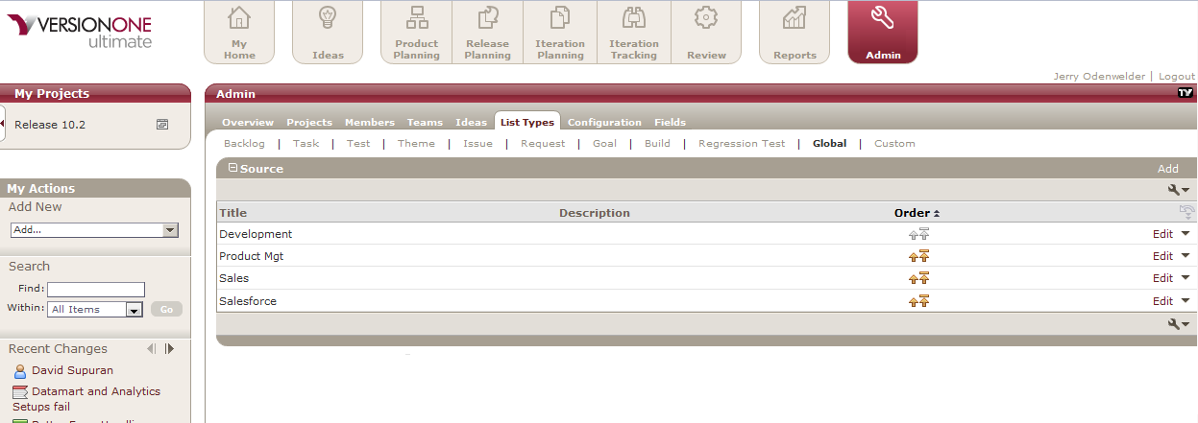

# Configure Salesforce.com

After installing CaseConnect you need to configure your Salesforce.com instance. To configure your Salesforce.com instance you need to:

1. Add your VersionOne instance as a valid Remote Site in Salesforce.com.
2. Configure the VersionOne connection parameters
3. Configure your Salesforce.com PageLayout for Cases to include the necessary VersionOne fields.

The following sections describe how to perform each of these steps.

## Add a Remote Site

To access VersionOne from your Salesforce.com instance you need to add your VersionOne instance as a Remote Site. To access the Remote Sites page:

1. Click **Setup** to access the Personal Setup page
2. Expand **Security Controls**, which is located under Administration Setup
3. Click **Remote Site Settings**

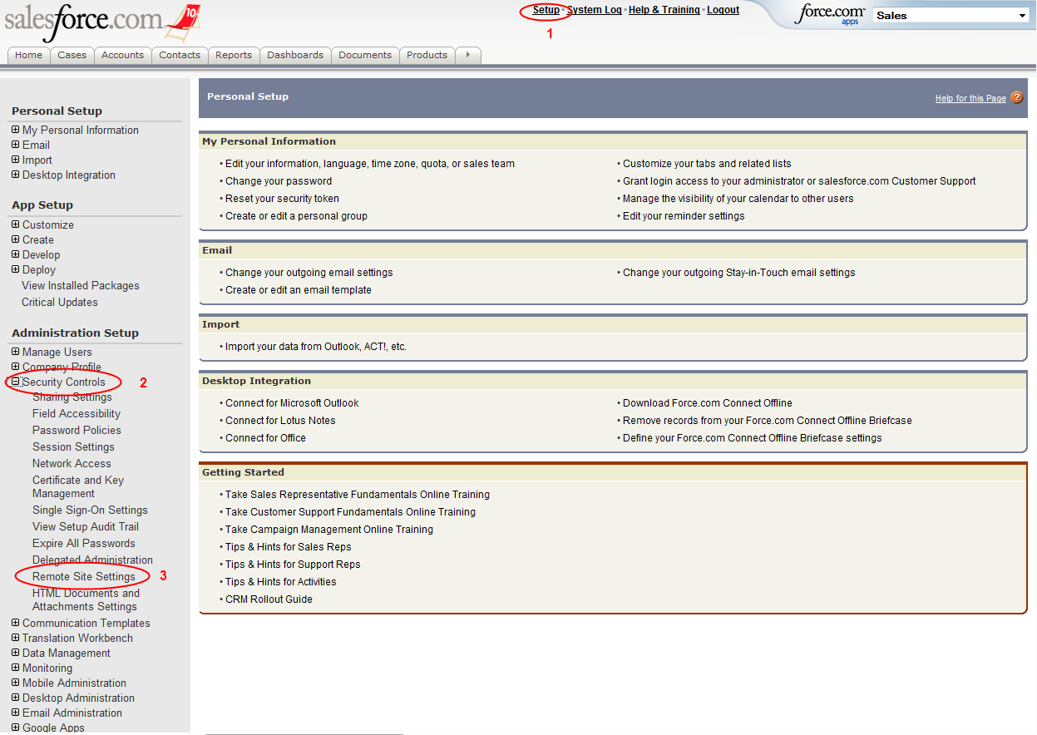

From this page, you need to click the **New Remote Site** button. To add a Remote Site you need to provide the following information

| Field Name | Description |
| --- | --- |
| Remote Site Name | A descriptive name for the remote site. |
| Remote Site URL | The URL for your VersionOne instance, without any page reference. |
| Disable Protocol Security | Do not select this checkbox |
| Description | Optionally provide some descriptive text. |
| Active | Check this box |

Once you’ve entered this information, click **Save** to commit the changes. The following image contains an example of a VersionOne Remote Site.

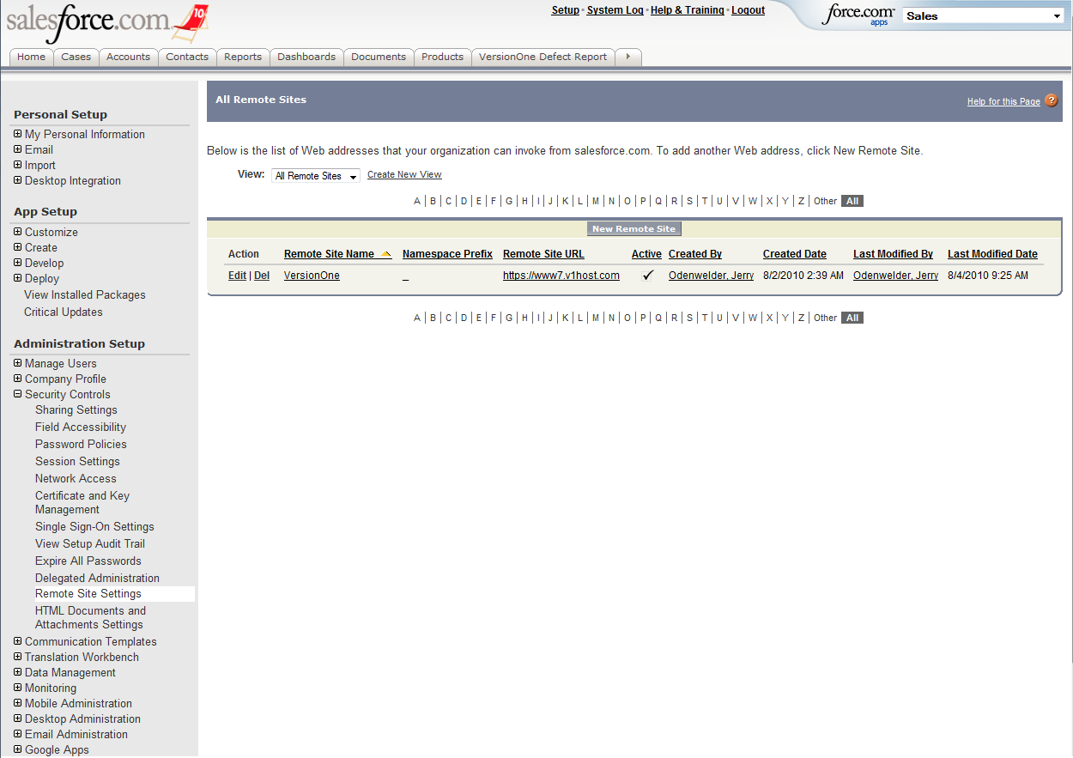

## VersionOne Configuration

The VersionOne configuration parameters are located in the VersionOne Settings tab. This tab is accessible from the All Tabs button.

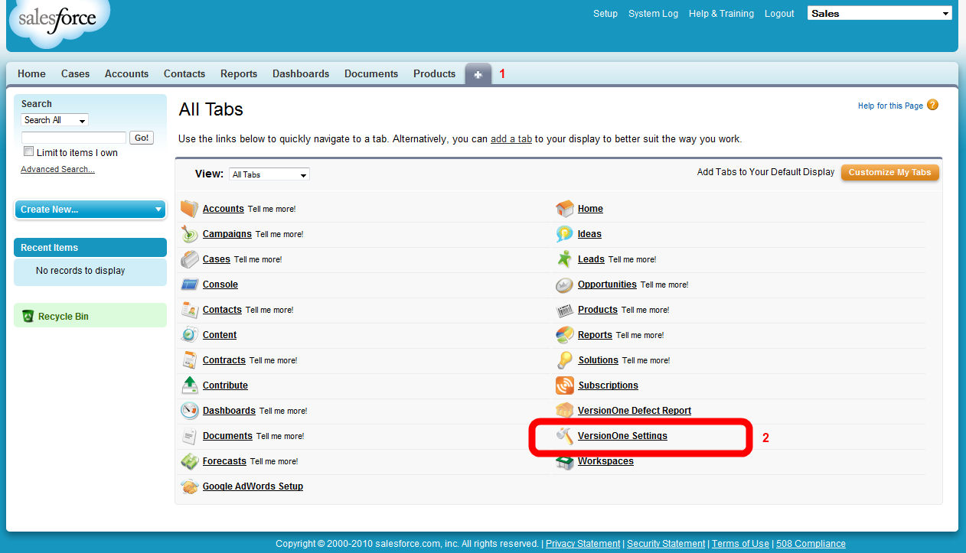

On the VersionOne Settings tab you must first provide the following information

| Field Name | Description |
| --- | --- |
| URL to VersionOne | The URL for your VersionOne instance, without any page reference. |
| Username | Username for a valid VersionOne member with access to the VersionOne projects where you want to create Defects. |
| Password | Password for specified user |
| Source | The Source list value you entered in VersionOne. By default this should be Salesforce |

After you enter this information, click **Test Settings** to verify that the parameters entered are valid. The following image illustrates a Salesforce.com instance with valid VersionOne parameters.

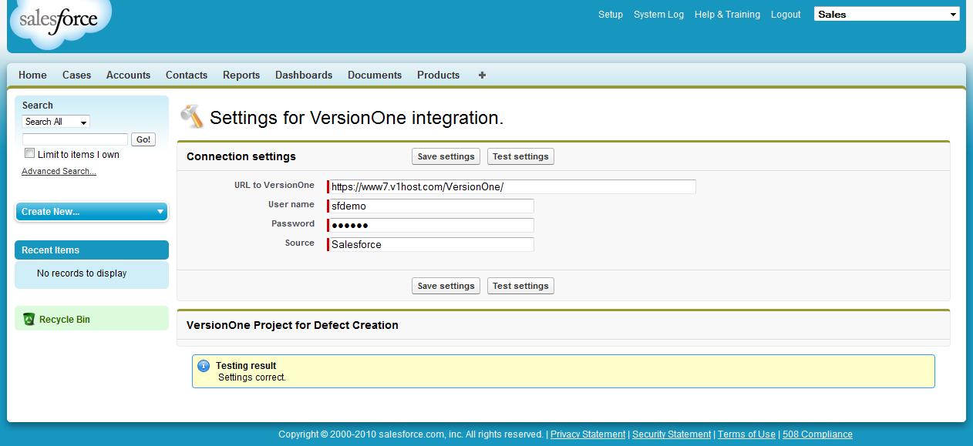

Once Salesforce.com indicates that the settings are valid (above image), click **Save Settings.**

After saving, you are allowed to specify where Defects are created in VersionOne.

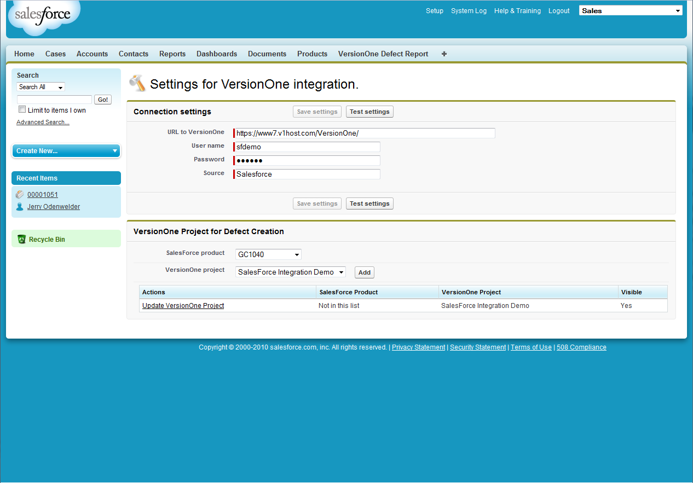

VersionOne Defects are created in VersionOne Projects based on Salesforce product codes. The first entry in the list is the Default Mapping, which is used when a Salesforce Product Code cannot be found in the list, or if the Product Code field is left blank. You cannot remove this entry, but you can choose which VersionOne Project is used. If you want to have all defects from Salesforce go into a single project in VersionOne, you would not need to create any additional mappings. Note: Using a single mapping is beneficial for initial testing because it limits where you need to look when creating defects.

To add a new mapping

1. Select a Salesforce Product Code
2. Select the desired VersionOne Project
3. Click **Add**

Once an entry has been added you can update the entry by making the desired change and clicking **Update** on the desired row. You may also remove an entry by clicking **Remove** on the desired row.

## Case Layout

The final step in configuring your Salesforce.com instance is to make the CaseConnect fields available to your Salesforce users. To modify the Case Layout

1. Click **Setup**
2. Expand Customize, located under App Setup
3. Expand Cases
4. Click on **Page Layouts**

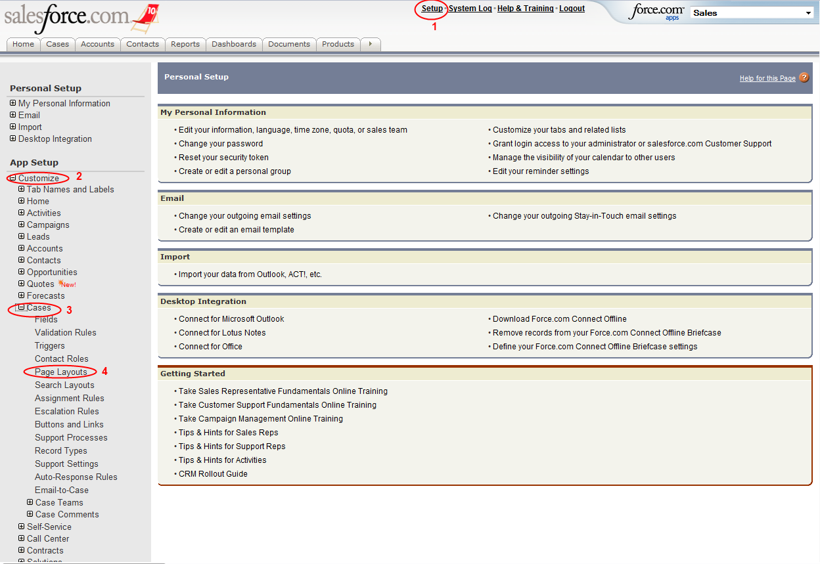

On the Case Page Layout page you will find a layout with the name “Case (VersionOne) Layout”.

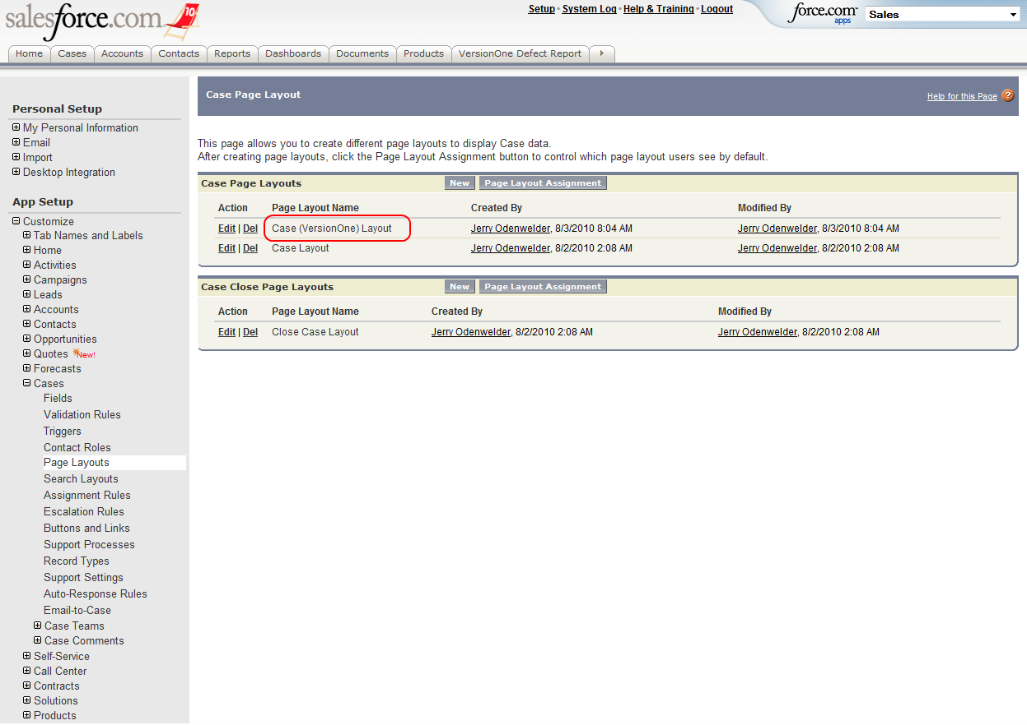

This layout contains all of the CaseConnect fields, but it does not contain any Case Page Layout customization you may already have in your environment. It is included in the CaseConnect package for testing and as a model if you need to add the CaseConnect fields to an existing Case Layout. If you have not customized your existing Salesforce.com Case Layout, you may find that replacing it with this layout is satisfactory. Detail instructions for replacing a Case layout are found in the Salesforce.com Help system. In short you need to:

1. Click **Page Layout Assignment**
2. Click **Edit Assignment**
3. Select the Profiles you wish to modify
4. Select the desired Page Layout. For example, select “Case (VersionOne) Layout”
5. Click **Save**

The following sections describe the CaseConnect Fields in more detail.

### CaseConnect Fields

CaseConnect requires 2 fields and 2 Visual Force Pages on the Case Layout.

| ID | Field Name | Description |
| --- | --- | --- |
| 1 | VersionOne Development Status | A text field that holds the VersionOne Development Status value once it’s published. |
| 2 | Search VersionOne Defects | A Visual Force Page that allows users to Search VersionOne for Defects matching the provided criteria. Users can assign a defect from the search results. |
| 3 | VersionOne Defect | A Visual Force Page to displays information about the associated VersionOne Defect. Once a Defect is associated, users can choose to publish the VersionOne defect status or unassign the VersionOne Defect. The VersionOne Defect Status is published to the “VersionOne Development Status” field on the Salesforce Case. |
|  | VersionOne Association | A read-only hidden checkbox that indicates if the Case has a VersionOne association. This field is used by the integration and should not be manually edited. This field is not visible on the image below. |

